Created Script Locally and Initialized Git Repo & Pushed to Git:
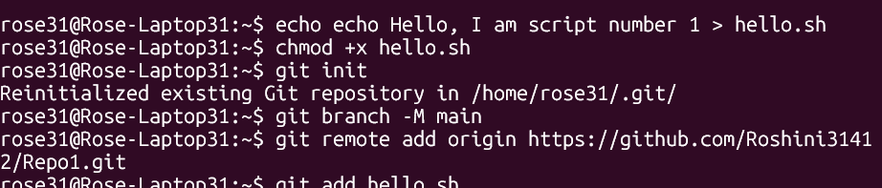
Jenkins Project Setup (Freestyle project name: Testing) and Build was success:
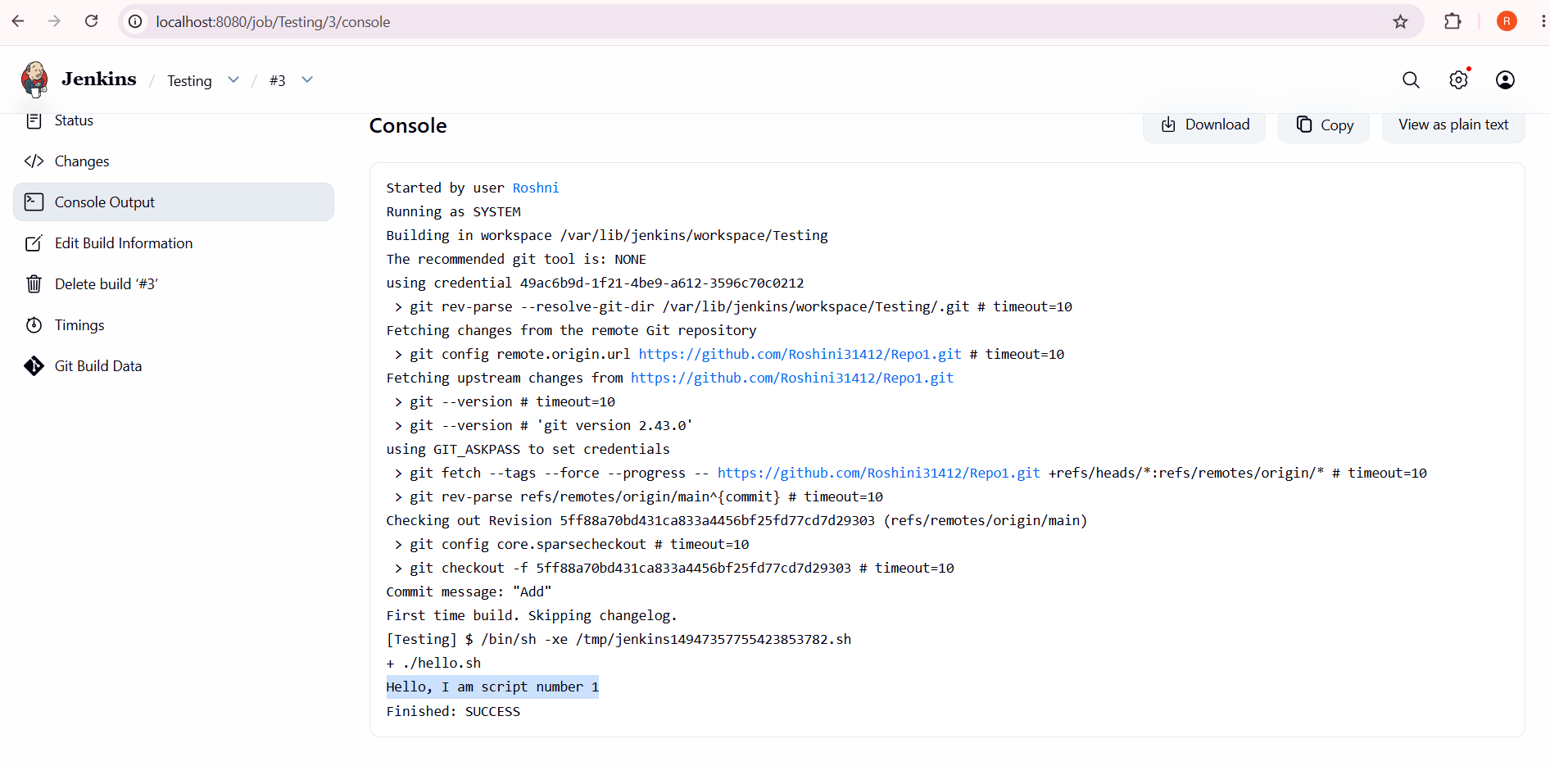

GitHub Webhook Setup:
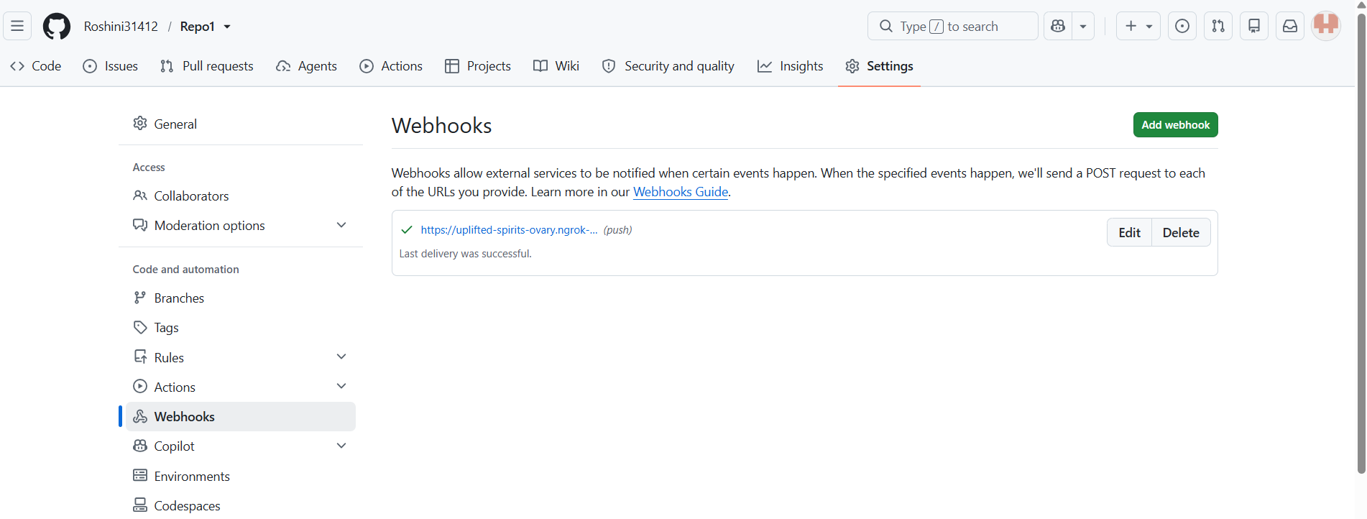

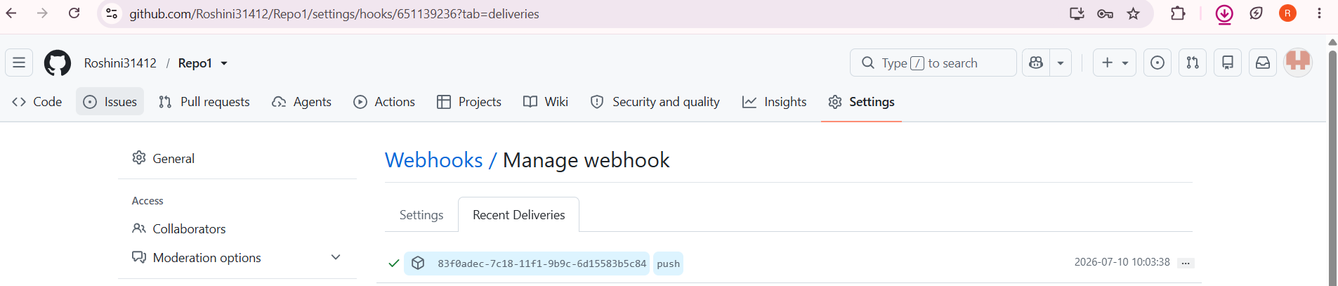

Automatic build in Jenkins after Webhook:
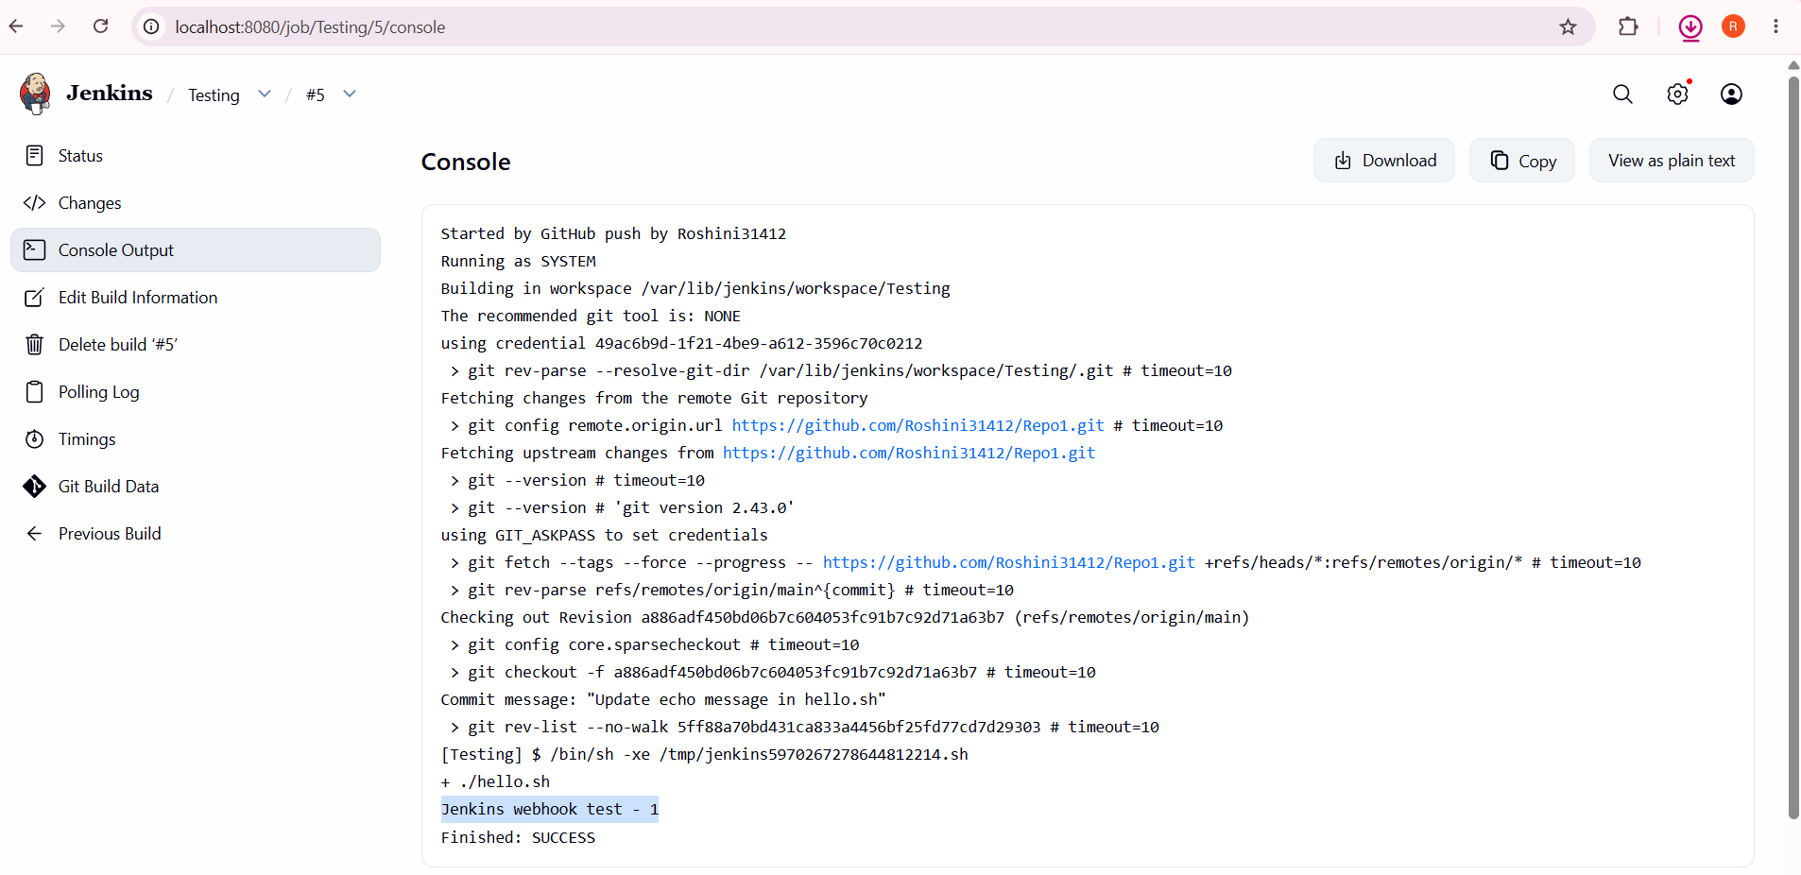
Jenkins Email Notification
- Tested Email is working fine
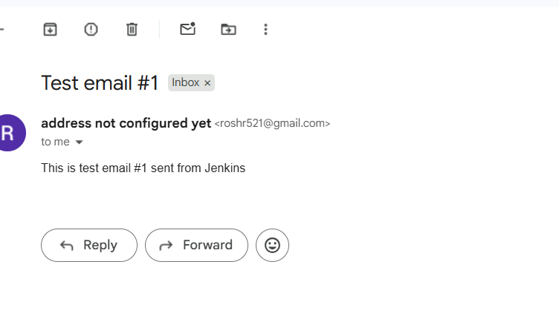
- After committing changes: Build success
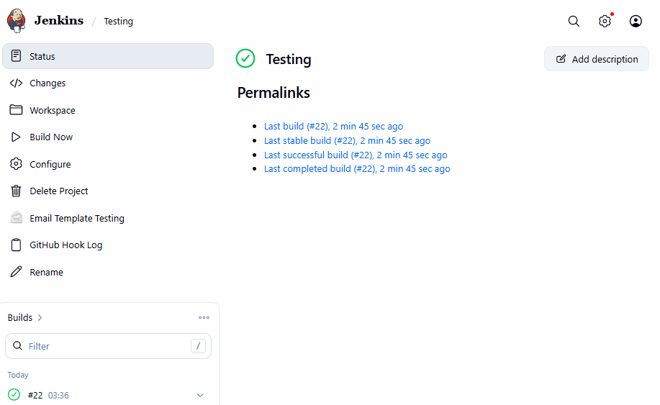
Output : RECEIVED EMAIL NOTIFICATION:

